What is react component lifecycle:
a. In React, the term "component lifecycle" refers to the series of methods that are invoked at different stages of a component's existence.
b. These stages of lifecycle component
i. created (mounted)
ii. updated and
iii. removed (unmounted) from the DOM.
In class based comp there component life cycle method -
a. componentDidMount () -
it invoked immediately after component mount
b. componentDidUpdate()-
i. This method is invoked(call) immediately after the component's updates are applied to the DOM
ii. It is called every time the component re-renders due to changes in its props or state
c.componentWillUnmount() -
i. This method is invoked immediately before a component is unmounted and destroyed.

useEffect() hook -
1 . useEffect hook is allow you to perform side effect in react application.
2. side effect refers as a fetching api data from server, subscribe event etc
3. Syntax -
a. useEffext hook have one callback function, dependency and cleanup function
b. useEffect (()=>{ callback function....,cleanup function}, [dependecy])
c. To properly handle side effects that need to be cleaned up before the next effect runs or when the component is unmounted.
d. blank [] - component re-render only one time
e. [ count === 5 ] - component re-render on specified condition

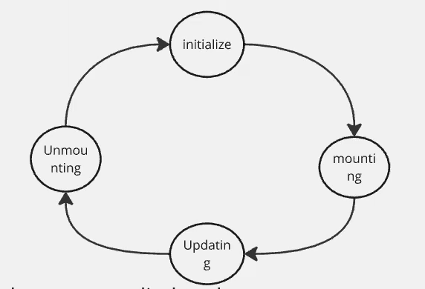
Initialize create component
Mouting component shows in browser
Updating component update (state)
Unmounting component delete

